**Assignment - 02-May-2022**

1. **What are the basic components of a computer system? And what are the measurement units of it?**

* Central Processing Unit (CPU) - Measured in Gigahertz.
* Random Access Memory (RAM) - Measured in Giga Bytes.
* Hard Disk Drives (HDD) - Measured in Giga Bytes.
* Network Interface Card (NIC) -Measured in Mega Bytes for seconds.

**2.What is an EC2 instance??**

An Amazon EC2 instance is a virtual server in Amazon's Elastic Compute Cloud (EC2) for running applications on the Amazon Web Services (AWS) infrastructure. AWS is a comprehensive, evolving cloud computing platform; EC2 is a service that enables business subscribers to run application programs in the computing environment. It can serve as a practically unlimited set of virtual machines (VMs).

Amazon provides various types of instances with different configurations of CPU, memory, storage and networking resources to suit user needs. Each type is available in various sizes to address specific workload requirements.

Instances are created from Amazon Machine Images ([AMI](https://www.techtarget.com/searchaws/definition/Amazon-Machine-Image-AMI)). The machine images are like templates. They are configured with an operating system (OS) and other software, which determine the user's operating environment. Users can select an AMI provided by AWS, the user community or through the [AWS Marketplace](https://www.techtarget.com/searchaws/definition/AWS-Marketplace). Users also can create their own AMIs and share them.

**3.What are the benefits of EC2 instance?**

* Elasticity in nature.
* Flexible.
* Inexpensive.
* More Secure.
* More Reliable.

**4.What is a customized AMI?**

Customized AMI is nothing but Where we can create our own AMI’s …

**5. What are the 3 categories of AMI?**

* Amazon Market Place.
* My AMI.
* Community AMI.

**6. How to create an ec2 amazon Linux 2 instance?**

Steps to create EC2 amazon Linux 2 instance :

1.Open EC2 and select instances.

2.Now click on launch instances button you will get this page.

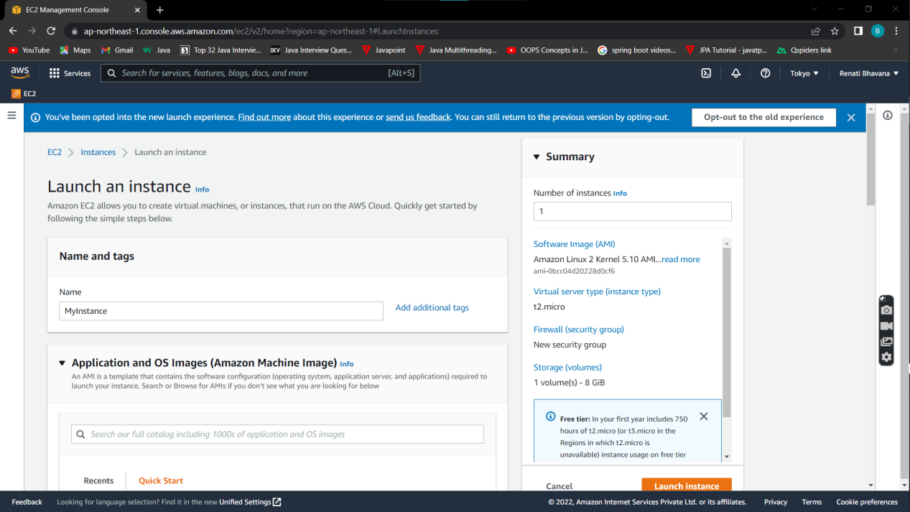

3.Provide all the details that are required like fill the name , mention the Amazon Linux 2 AMI (HVM) which is free tier.

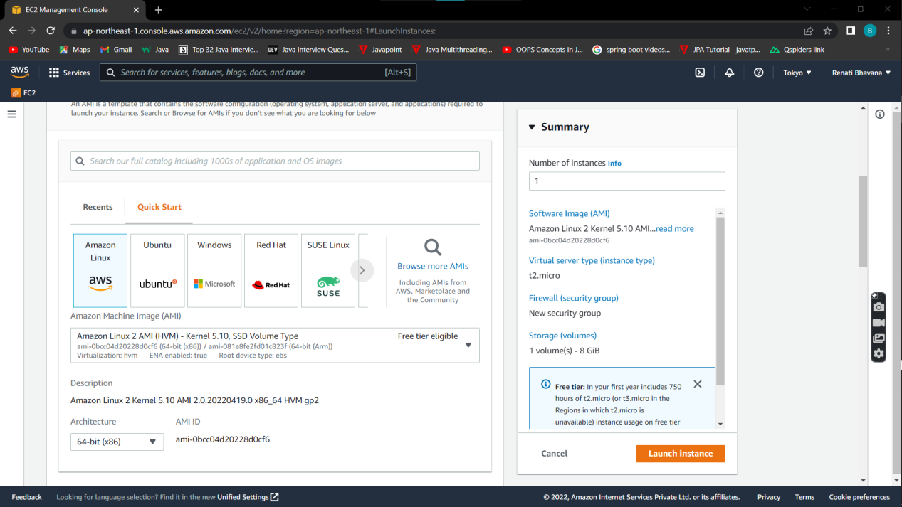

4.Choose the instance type as t2.micro.Select the Key Pair if you don’t have any KP ,click on Create new KP and create it......Choose the number of instances and click on Launch Instance button.

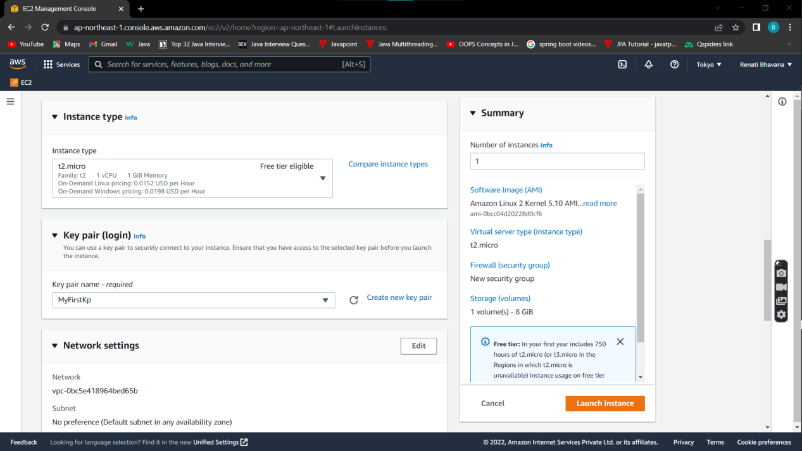

5.Now your instance is created and you will get success page .

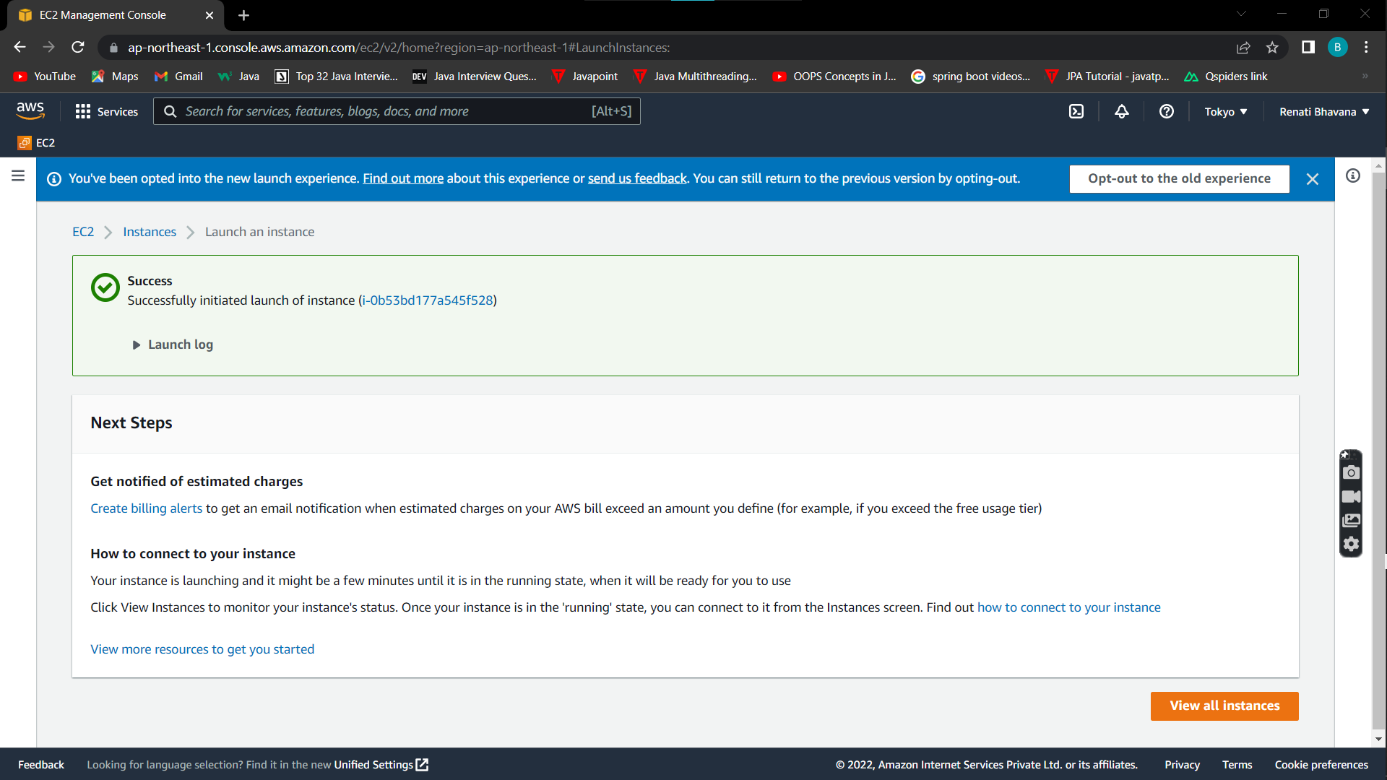

**7. How to connect to Amazon linux2 ec2 instance?**

Steps to connect to Amazon linux2 ec2 instance :

1.Once the instance is launched with the status check as 2/2 , highlight the created instance and above u will find the connect button … click on that…….

2.Once u clicked on connect u will navigate to this page and click on connect button.

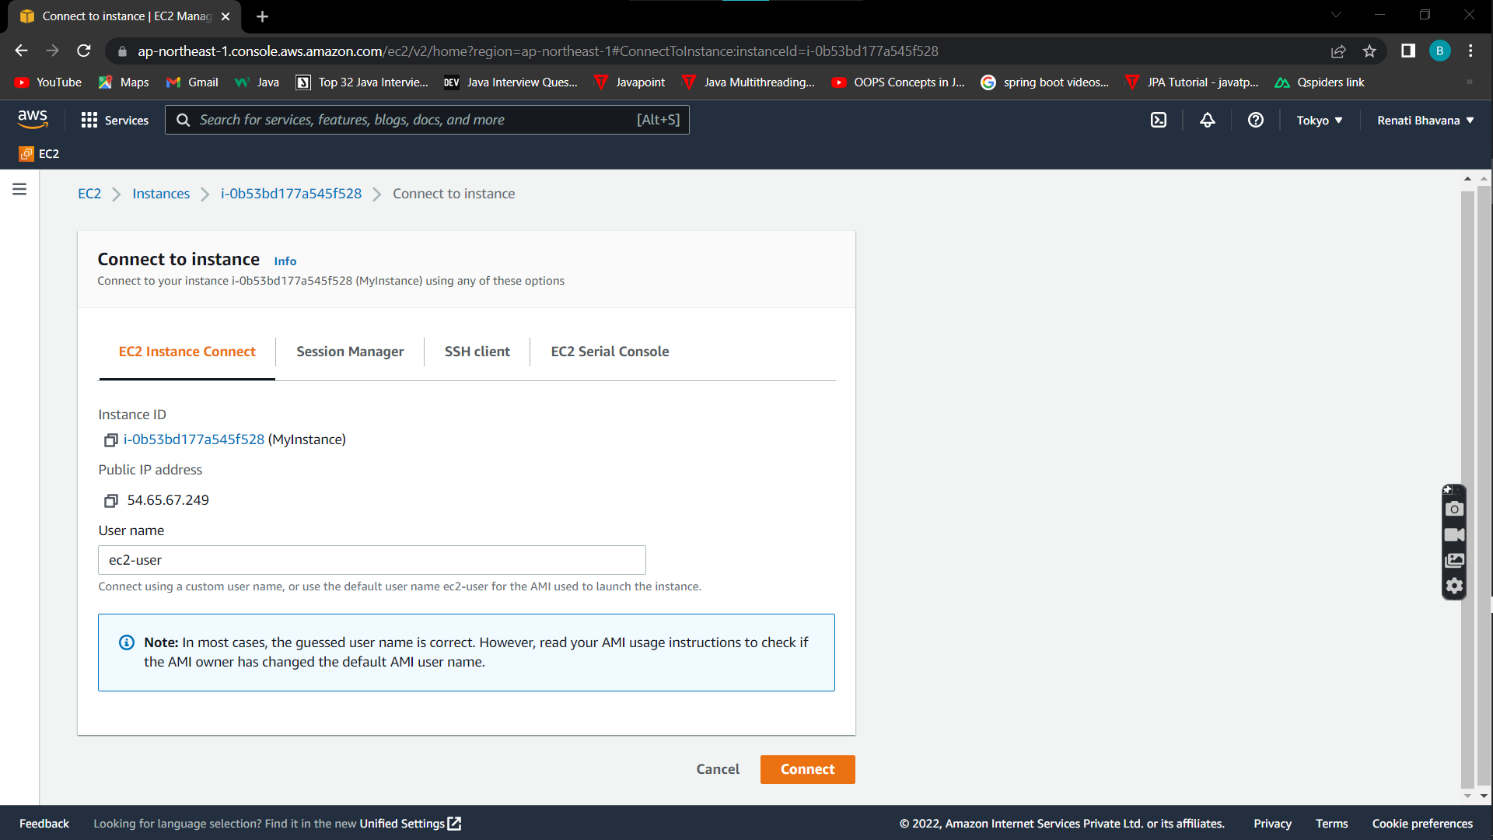

3.Once it done u will get cmd prompt.

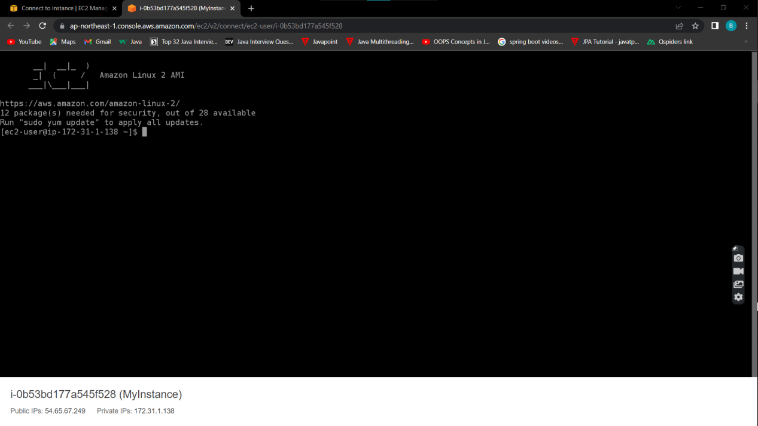

**8. How to change the ec2 instance type?**

1.We have option called Actions button, extend that Actions button .

2.You will find instance settings ..in that choose instance type.

3.Here we can change the instance type.

**9.How to terminate the ec2 instance?**

In instance state we have a option called terminate instance ,click on that u will get confirmation page to proceed the process , click on continue to terminate .Instance gets terminated.

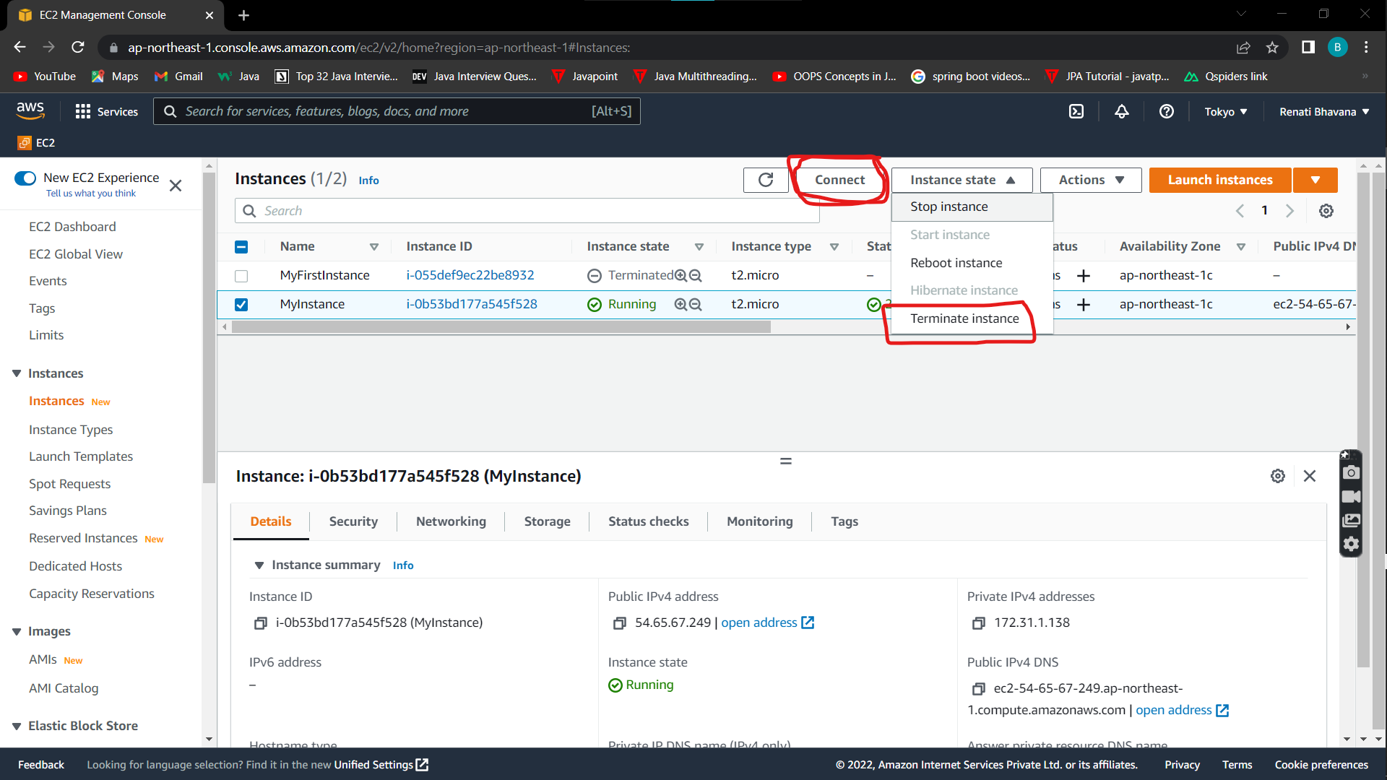

**10. How to shutdown the ec2 instance?**

In instance state we have a option called Shutdown instance ,click on that shut down , the instance will get shutdown .

**11. How to restart an ec2 instance??**

In instance state we have a option called Restart instance ,click on that restart instance, the instance will get restart.

**12. What is an Elastic IP?**

Elastic IP address is a public ****static IPv4 address**** which is reachable from the Internet. Basically Elastic IP addresses are used by AWS to manage its dynamic cloud computing services. Within the AWS infrastructure, customers have virtual private clouds (VPC), within the VPCs, users have instances. So when you launch an EC2 instance, you receive a Public IP address by which that instance is reachable from internet. Once you stop that instance and restart the instance you get a new Public IP for the same instance. So it's basically a problem to connect your instance from internet for not having a static IP. To overcome this problem, *we attach an Elastic IP to an Instance which doesn't change after you stop / start the instance*.

In short Elastic IP is a permanent IP for your instance.